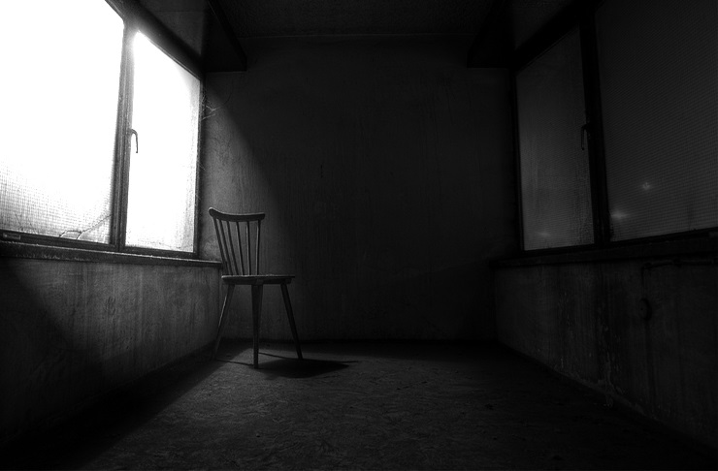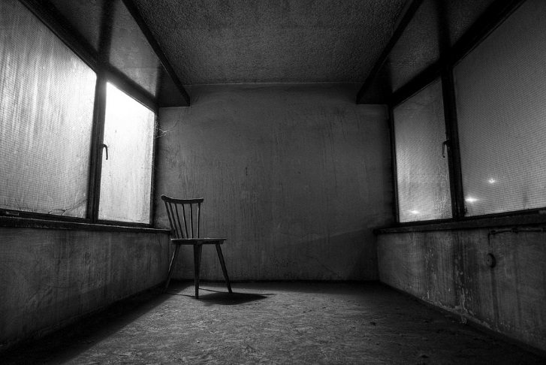To create this poster I used Photoshop. I started with a base image of an interrogation room with a window and one empty chair; I knew I wanted to build a foundation with that image as soon as I opened the canvas in Photoshop. First, I decided to adjust the contrast, contrast is the difference between black and white, as the room was unsaturated the contrast would cause an awesome creepy aesthetic. I then proceeded to add a lighting effect on the window so it would look like the light from outside was being shot through the window.

AFTER

BEFORE

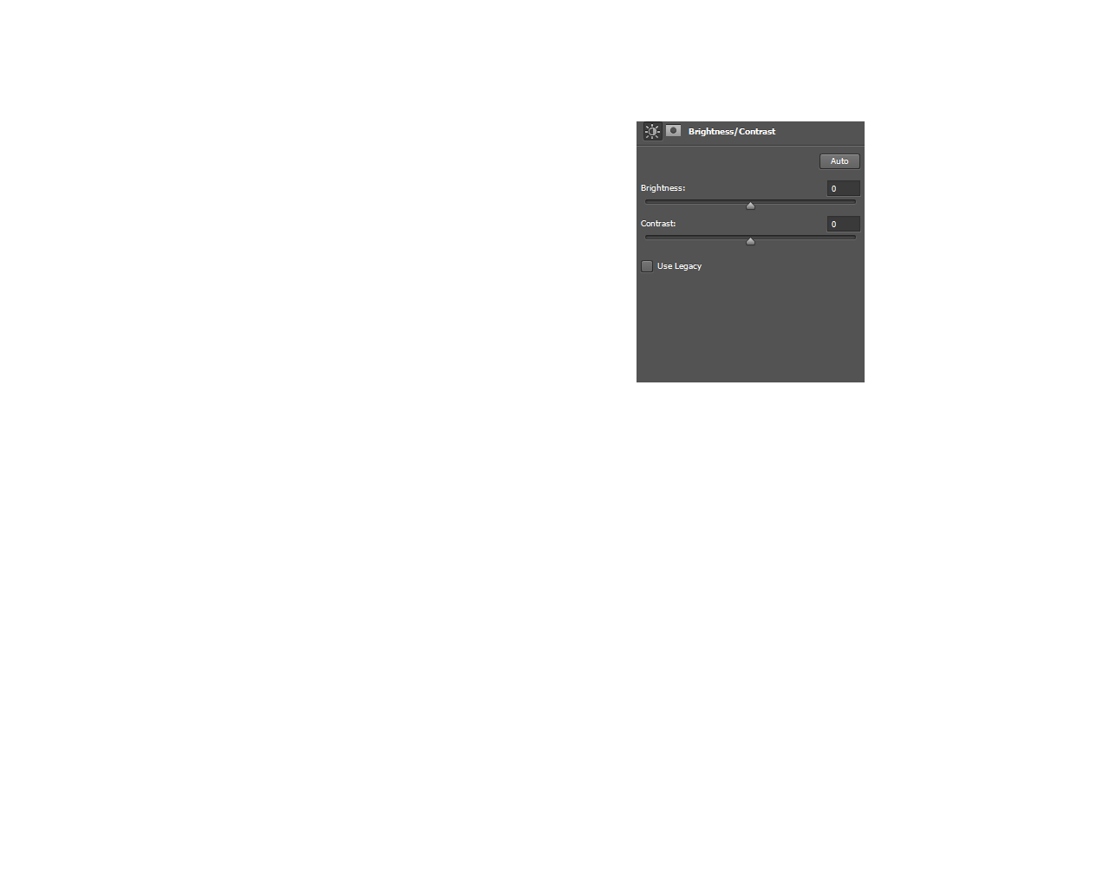

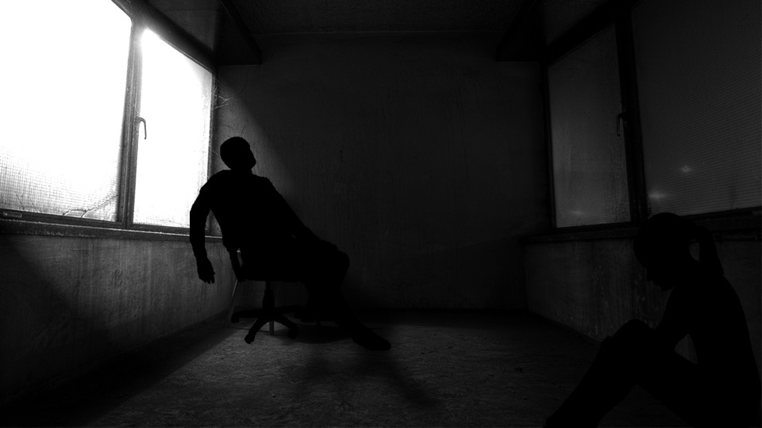Once I had creted the ambience of the poster I started to add some character silluiettes to close the space and make the image look more interesting. I also had to use the blending mode in photoshop to create a shadow of the silluette becaues of the lighting effect, this effect was very simple.

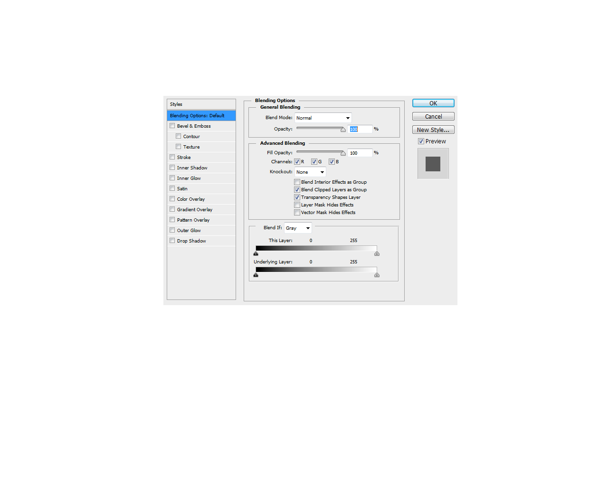

At this point the poster was almost complete, I decided to add one more silluette because it felt uneven. I also added a film title behind the sillueete and used blending options to give the text a wore out jugged look. The credits were also added to the bottom of the poster for a professional touch.

