**Research Report – Danny Withers**

**Introduction**

For our final major project, we have to find and collate different forms of research. We have to research maybe certain film and genres because we must have an idea of what we are going to create, there are multiple types of research, both primary and secondary, primary research is research that you found from other people, research what has not been discovered by someone else such as a questionnaire or a survey. However secondary research is easier to get hold of, this is research which has been found by someone else and published, this is good research to an extent however you are going to have less knowledge of how the information was received you also don’t know if the website or where ever you found it from may not be truthful, it may be false.

**Methodology**

I found the primary research by using a website called survey monkey, this website allows you to create any survey you like and anyone can answer it, this is pure research what has never been created before, this makes the research legit unlike secondary research this information to me is what I have discovered. Secondary research is found through the internet, this is easier as the information is faster to find however, there is a website called Wikipedia, which allows people to add any research that they want this allows some false information to be passed through for other people to use as research. However some sources are legit and do have solid information. Our focus group is around the age of 16-50, this means that the research can be slightly more explicit and we can open up some more space to find certain information. I got these results below from my survey monkey questionnaire.

**Results**

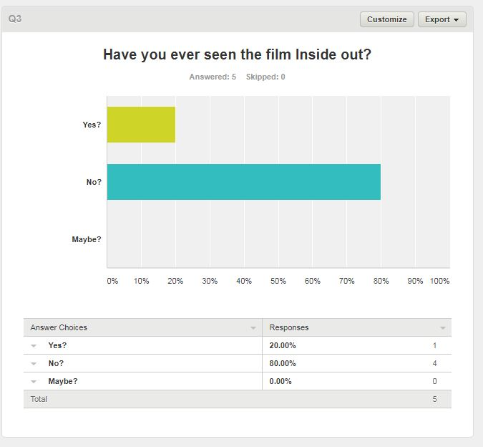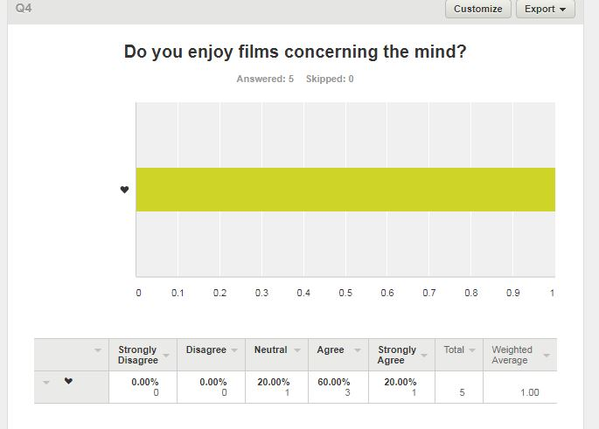

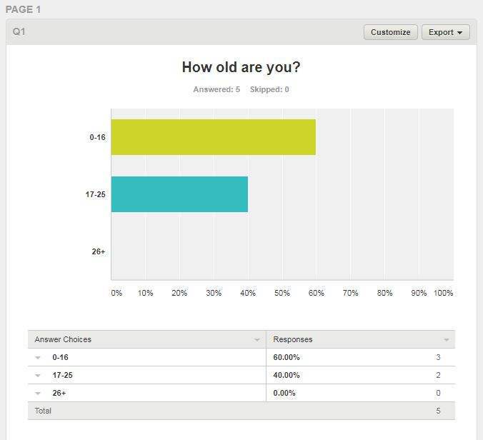

**Conclusion**

These results show all the answers I received from my survey monkey questionnaire in a bar chart form, only 5 people answered my survey however it still gives me an accurate no bias reason. This allows me to see what most people enjoy and what people do not enjoy because the results are very accurate and calculated.