# Persona Template for (Title of Music Video)

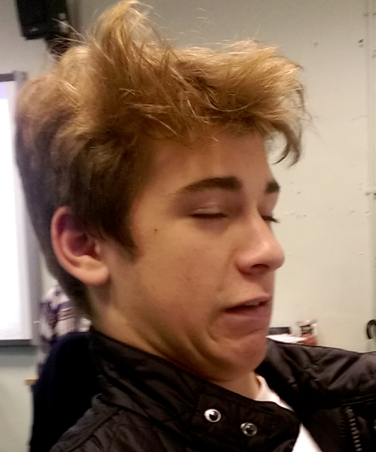

Note – use the relevant responses from your questionnaires to complete these sections

|  |  |
| --- | --- |
| Name: | Callum |
| Age: | 17 |
| Gender | Male |
| Education and Job Socioeconomic status: | CO-OP |
| Psychographic and justification: | Mainstreamer |
| Geodemographic and how this effects their tastes | White British |
| Common Behaviours | * (Bullet points) * Skater |
| What they like in a music video: | * (Bullet points) * Narrative |
| Viewing habits and music video consumption : | * (Bullet points) * Online |